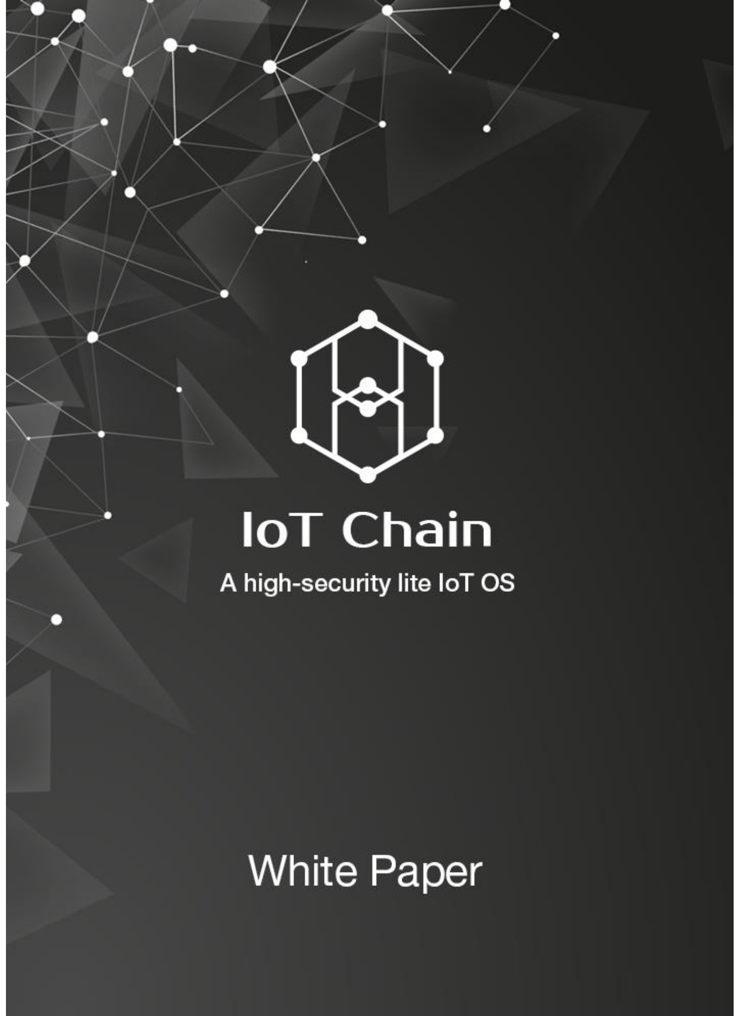

IoT Chain

I

**Contents**

**Chapter I Project Background 1**

**1. What is IoT? 1**

**2. Market scale of IoT 1**

**3. Challenges 4**

**4. Solutions 6**

**Chapter II Project Exposition 9**

**1. Brief introduction 9**

**2. Technical architecture 9**

**3. Our Architecture 16**

**4. Product planning 17**

**5. Cooperative partners 19**

**Chapter III Team Members 23**

**【Core Team】 23**

**【Consultant Team】 24**

**References 26**

**Chapter I Project Background**

**1. What is IoT?**

Based on internet, traditional telecommunication network and other information carriers, IoT (Internet of Things) is the network that enables interconnection between all ordinary physical objects which can be located independently. IoT has three key features: the equalization of ordinary objects, interconnection of automatic-management terminals and intellectualization of pervasive services. Through IoT, all the things can be connected to the internet for information exchange and communication to realize intellectualized recognition, location, tracking, monitoring and management.

There are two implications of IoT. First, internet is still the core and foundation of IoT, which is extended and expanded on the former. Second, the user-end of IoT has extended to information exchange and communication between all things, namely the thing to thing interconnectivity. IoT has been applied widely in network convergence by means of communication perceptive technologies such as intelligent perception, recognition and pervasive computing. Therefore, IoT has been called the third wave of the world’s information industry development following the computer and internet. Since IoT is an expansion of internet, it should be referred as business and application rather than network. Hence, innovation of application is the core of IoT’s development and creation centered on user experience is the soul.

**2. Market scale of IoT**

Since the development policies of IoT were brought up by America, European Union and China in 2009, IoT has been developing with a fast pace. Traditional enterprises and IT magnates have all made efforts to take part in IoT, which has penetrated rapidly into many fields, such as manufacturing industry, retail industry, service industry and public utilities. Now, the IoT is on the eve of explosive growth on a large scale. According to *2016 China IoT’s Market Scale and Development Trend* issued by Wulian Zhongguo, the global IoT market scale reached 62.4 billion dollars in 2016, with a year-on-year growth of 29%. In 2018, the figure is expected to reach 103.6 billion dollars. From 2013 to 2018, the compound growth rate will be 21% and the number of newly-increased IoT devices will rise from 1.691 billion in 2015 to 3.054 billion in 2019 (See Figure 1).

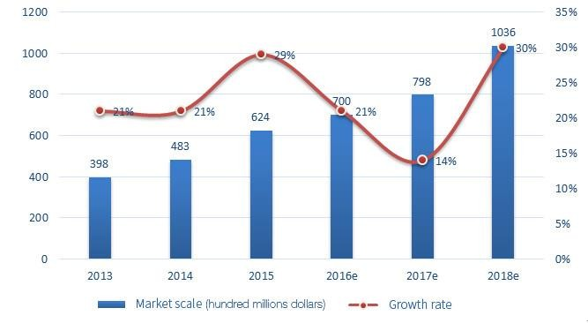

Figure1: 2013-2018 Global IoT Market Scale and Growth Rate

More and more articles and devices are being connected to IoT. According to Gartner, though the world’s population is 7.5 billion, the number of global IoT devices will increase from 6.4 billion in 2016 to 8.4 billion in 2017, with a 31% growth rate. The number of IoT devices will exceed the sum total of PC, tablet PC and smart phones in 2018 and reach 20.4 billion in 2020 (See Figure 2).

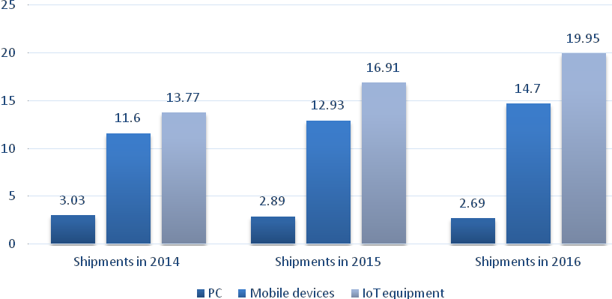

Figure 2: 2014-2016 Global IoT Market Scale and Growth rate

According to IHS Markit, most articles will be intellectualized by 2025. In the future, everything will be interconnected, from a cup to a house, and IoT will spread across every aspect of our life (See Figure 3).

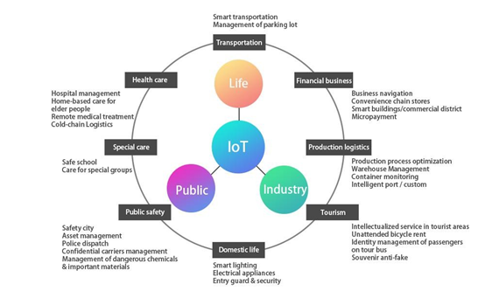

Figure 3: Application fields of IoT

In 2016, the whole world’s expenditure on IoT technical products and services enterprises has reached 120 billion dollars and this number will increase to 253 billion dollars in 2021 with 16% annual growth rate, among which the pure IoT technical services expenditure will reach 143 billion dollars with 17% annual growth rate. Based on assumption of 20% annual growth rate, Asia will have the fastest growth and take up around 35% of worldwide IoT expenditure in 2021.

**3. Challeng**

Challenge 1: Traditional attack techniques damage IoT devices wantonly

【Challenge】The Botnets of Things created by Mirai was entitled as one of the Ten Breakthrough Technologies in 2107 by *MIT Technology Review.* According to the statistics, the Botnets of Things have infected more than 2 million IoT devices, for example, the cameras. The DDos attack launched by this made the network of American DNS service provider Dyn break down and users could not visit several popular websites such as Twitter and Paypal during a short period. Afterwards, more botnets appeared, including the one that hijacked the IoT devices to mine Bitcoins and the http81, which has larger scale and is more active.

Centralized management structure cannot prove its innocence and individual private data leak has happened occasionally. For example, in May, 2017, People’s Daily Online once reported that 266 cameras in Chengdu were enforced for webcast.

At present, the security model based on closed source (often called “security through obscurity”) has exposed its potential safety hazards and will be abandoned gradually and be replaced by a new security model, “security through publicity”. To realize this, it is necessary to upgrade the model to open source software. Though the current open source systems are still vulnerable to accidents and are of low availability, they are less prone to government interference and other targeted attacks. Therefore, the open source systems will play an important role in home automation as well as networking of vehicles and other devices.

【Solution】IoT Chain (ITC) has adopted the asymmetrical encryption. As long as the private key is kept properly, the data cannot be cracked even if it’s collected. At the same time, all the nodes in ITC are equal, which protects the users’ privacy. Moreover, based on the character that block chain cannot be tampered, the manufacturers and service providers won’t be able to tamper users’ any information.

Challenge 2: High cost of centralized architecture

【Challenge】Before the revenue of IoT reaches market expectation, the costs of IoT are still extremely high. Most exiting IoT solutions require huge investments: apart from the commission for intermediaries of these services, building and maintaining the infrastructure related to centralized cloud and large-scale server cluster are very expensive as well.

Unfortunately, current IoT solutions fail to match the service supply and customer’s expectation. In the past, the cost and revenue of IT industry were always consistent. For the large-scale server, during its long lifespan, it will receive long-term service since the manufactures and the buyers have signed support contract. For personal computer and smartphones, though there is no high-profit support plan, this won’t be a big problem because of their short lifespan.

But for IoT, the equipment manufacture enterprises don’t have enough profits to make up the money for supporting and maintaining the equipment for a long period. Meanwhile, it will cost numerous money to serve hundreds of billions of smart devices, let alone the high maintenance fees of centralized server for distributing and updating software.

The operating costs of WeChat servers for 600 million users have reached above

300 million Yuan per month. Now there are 4.9 billion devices online, the annual operating costs of servers will be 29.4 billion Yuan and the number is still increasing rapidly every year.

【Solution】The future ITC shall have tens of thousands of nodes and they will be absolutely adequate to meet the needs of IoT data storage with a combination of blockchain’s distributed ledger technology. And thanks to the de-centralization of blockchain, there is no need for highly-intensive computer cluster. Both technologies have dramatically reduced the operating and maintaining costs of the whole IoT.

**4. Solutions**

(1) The concept of blockchain

Blockchain is an important concept introduced with Bitcoin and its essence is a decentralized database. In a narrow sense, blockchain is a sort of chain-data structure where data blocks are linked in accordance with time sequence. It is also a distributed ledger which cannot be tampered or counterfeited under the protection of cryptology methods. In a broad sense, blockchain technology is a brand new distributed infrastructure and computing paradigm which uses chain-data structure to verify and store data, uses distributed node consensus algorithm to generate and update data, uses cryptology methods to guarantee the safety of data transmission as well as data access and uses smart contract composed of automatic script code to program and operate data.

In a more colloquial way, blockchain technology enables everyone to take part in the bookkeeping. There is a database behind every system and if we regard the database as a large ledger, the person in charge of bookkeeping is quite important. Under current technical situation, the person who owns the system is responsible for the bookkeeping. For example, Tencent is in charge of the bookkeeping of WeChat and Alibaba is in charge of Taobao. In the blockchain system, everyone will have chance to involve in the bookkeeping process. During a certain period of time, if there is any change in data, everyone in the system can participate in bookkeeping. The system will select the fastest and the most qualified user to write his record on the ledger and then distribute the updated ledger copies to other users in the system as backup. Therefore, everyone in the system will have a complete ledger. This kind of bookkeeping method is called the blockchain technology.

(2) The advantages of blockchain technology

The idea of everyone in charge of bookkeeping has brought obvious advantages:

1. High security: The basic architecture of blockchain is immune to traditional internet attacks. The feature of IoT’s information encryption and secure communication is security through publicity, and this will help protect users’ privacy. Management of identity access and multi-party consensus will contribute to the recognition of misbehaving nodes and prevent malicious nodes from accessing or destroying the network. The structure based on chain data will be conducive to building electronic evidence which can be testified and traced.

2. Low costs: The features of decentralization, multi-centers and weakening centralization will reduce the operation cost of centralized architecture.

(3) The barriers to blockchain application

Objectively speaking, although blockchain has many distinctive merits, there are still quite a few barriers to its widespread application. Let’s take Bitcoin as an example:

1. Resource consumption: Bitcoin’s POW (Proof of Work) is consensus mechanism with high resource consumption, while most IoT devices have problems like low computing ability and network capability as well as short battery life.

2. Data expansion: With the growth of blockchain, can IoT devices provide enough storage capacity? Until now, Bitcoin needs 100 G physical storage space and the number keeps increasing. If the blockchain technology were widely used, the demand for storage space would be enormous.

3. Performance bottleneck: The limit speed of traditional Bitcoin trade is 7 transactions per second and it will take about one hour to write in the blockchain plus the time for consensus confirmation. This will lead to feedback and warning delay, which are infeasible for delay-sensitive industrial IoT.

4. Partition tolerance: The industrial IoT emphasizes that the nodes should be “always online” but it happens all the time that ordinary IoT node fail and rejoin the network back and forth. This will generate network shocks which consume a lot of network bandwidth and even cause “network partition”

All the above problems are not obvious when the blockchain is used on a small scale, but they will be big headache in large-scale applications. How can we solve these problems?

**Chapter II Project Exposition**

**1. Brief introduction**

Due to the centralization design of traditional IoT architecture, the users’ behavioral data is stored in the center servers controlled by merchants. Thus, the users’ data is prone to be leaked out and the users’ privacy as well as safety will face severe threats.

The blockchain has provided decentralized ideas and technology, which are very suitable for the self-service, self-maintenance, self-transactions and shares between machines in IoT industry [1]. But there are still some key problems to be solved when applying the blockchain technology in IoT, such as the form of consensus, quick pay on small amount and protection of data privacy. For these problems, IoT has brought up its own solutions, including PBFT, SPV, DAG, CPS cluster technology, big-data-analysis smart contract ChainCode and so on.

ITC adopts the main chain of PBFT consensus, the DAG network, which supports high performance by nature, as side chain and the multi-tier architecture to build an IoT operating system which is safe, decentralized and can support high concurrency.

**2. Technical architecture**

**(1) PBFT**

One of the core problems of Blockchain is establishing consensus between nodes. Different consensus algorithms will create different performance. ITC applies PBFT consensus algorithm to achieve main chain consensus (See Figure 4). Practical Byzantine Fault Tolerance (PBFT) is a state machine replication algorithm based on the consistency of message passing [2]. Through three stages, namely pre-prepare, prepare and confirm stage, this algorithm provides a fault tolerance of (N-1)/3 (N is the total number of nodes) on the premise of ensuring the activity and safety [3].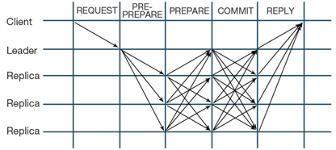

Figure 4: The process of achieving consensus of PBFT algorithm

Though using PBFT algorithm may cause some losses in the extensibility of nodes, both extensibility and performance needs can be balanced by adjusting the weight. The blockchain technology based on PBFT consensus algorithm has been applied in digital currency of Central Bank of China, Bumeng Blockchain and IBM’S hyperledger. Recently, the HoneyBadgerBFT consensus protocol has been put forward, which is said to have realized asynchronous BFT protocol [4].

By adopting PBFT consensus protocol, ITC has greatly improved the main chain’s processing performance on the premise of achieving consensus of main chain’s decentralization.

**(2) DAG**

Bitcoin has recently had a hard time with SegWit expansion solution. Owing to the linked-list data structure of blockchain itself, Bitcoin’s transaction performance has become worse and transaction fees is growing higher and higher. DAG is a distributed architecture without any block and it applies Directed Asyclic Graph architecture [7] (See Figure 5) instead of the heavy linked blockchain structure. Compared with Bitcoin’s longest-chain consensus, DAG changes this into heaviest-chain consensus mechanism, confirming a new deal through transaction weight and partial consensus among nodes, which binds proof of work with each deal skillfully. This not only solves the present problem of centralization of Bitcoin’s mining but also greatly improves the whole distributed network’s throughput capacity, lowering the transaction costs. After analysis, we think DAG will become the basic data structure for the next generation’s blockchain.

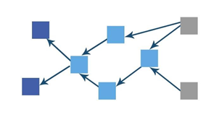

Figure 5: DAG topological structures

In DAG network, in order to start a transaction, the node needs to do simple proof of work and pack several unconfirmed transactions into its own one. When new child transactions confirm parent transactions, partial consensus will be established. The more nodes are related to the parent transaction, the easier it will be for the transaction to be confirmed. All transactions issued by these nodes form this Directed Asyclic Graph set. The confirmation of new transaction is determined by former transaction’s weight. By optimizing node selection algorithm and setting transaction weight, over dispersion of DAG and hashrate attack of illegal transactions can be avoided to protect high efficiency and security of transactions on the chain. ITC adopts DAG’s data structure to solve performance problems. On the one hand, the transaction performance can be improved. On the other hand, ITC can resist quantum attack.

DAG’s twisted structure can naturally suit IoT’s message passing mode and can bring extremely high performance for ITC and satisfy blockchain’s decentralization and safety at the same time. ITC applies distributed POW and POS ideas —different IoT devices nodes can adopt different security levels according to their requirements — to satisfy various scenes in IoT ecosystem.

**(3) SPV**

SPV （Simple Payment Verification） is a technology which can conduct payment verification without maintaining complete blockchain information as long as the blocks’ headers are preserved. This technology cannot only save the cost of blockchain payment verification but also reduce the users’ burden. The design

principle of SPV was first introduced in Nakamoto’s Bitcoin: A Peer-to-Peer Electronic Cash System [5]. Taking Bitcoin as an example, payment verification can be conducted if the nodes preserve all blocks’ headers. If not, payment verification cannot be accomplished independently, but necessary information of payment verification can be obtained from other nodes of the blockchain to finish transaction payment verification and get the number of verified transactions in the whole blockchain network [6] (See Figure 6).

ITC nodes use SPV technology to solve the data expansion problem of major network and DAG. Improving payment verification efficiency is the key method to ensuring the whole network’s performance.

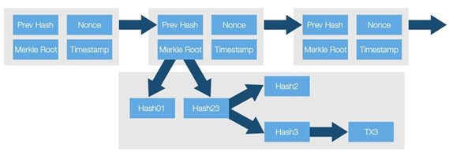Figure 6: SPV verification principles

**(4) Security Big-data Intelligent Analysis—Smart Contract ChainCode[1]**

ITC will become the most abundant data ecosystem in the generation of IoT and generate large amount of data based on smart devices and users’ behavior. Currently, the users’ data are monopolized by magnate companies and are violated all the time in business that abuses users’ data privacy, such as advertisement recommendation and information reselling.

In ITC, users’ data belong to themselves. Any company who intends to do big-data analysis or algorithm model training of advertisement recommendation need to submit Chaincode to ITC.

Using probability model algorithm such as hyperloglog bloomfliter and zero-knowledge proof, we can provide the necessary interface api for ChainCode data analysis.With the restriction and assignment of these interfaces, contracts submitted to ChainCode cannot steal the users’ initial data but can obtain aggregated data used for smart business decision.

After execution of ChainCode, the companies need to pay ITC token to users who provide the data according to the data value. In this way, ITC provides a big-data analysis ecosystem where both users and companies win.

**(5) CPS[2]**

“ITC + Intelligent analysis platform” big-data value-creation system will be needed if traditional production system is transformed into smart factories producing intelligent products. To meet this command, smart system focused on Cyber Physical System (CPS) has come into being. In essence, CPS is a multi-dimensioned smart technical system based on big data, network and mass computation. Through core technologies including intelligent sensing, analyzing, mining, assessing, predicting, optimizing as well as cooperating, CPS can integrate computing, communication and control for deep collaboration to realize profound integration between physical space

and cyberspace involving the object’s mechanism, environment and community [8].

The architecture of ITC refers to CPS cluster and builds CPS technical system structure on networks of five levels, including connection, conversion, cyber, cognition and configuration). On this system architecture, pluggable and independent blocks of network communications, data analysis and value transfer can improve the stability of IoT’s ecosystem in ITC and make it more intelligent (See Figure 7).

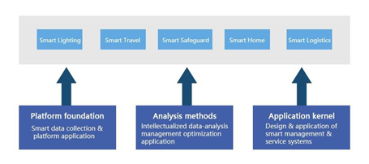

Figure 7: The interactive network of CPS technical system

In summary, with the application of SPV technology in nodes, PBFT consensus algorithm in main chain as well as reference to CPS IoT layered architecture and ingenious combination of DAG technology with main chain, ITC has realized the big-data analysis ecosystem which can satisfy IoT’s high-concurrency explosive usage scenarios, provide intelligent data analysis API and produce a win-win situation between users and customers on the premise of safety as well as decentralization.

Compared with traditional blockchain, ITC has distinctive advantages in system configuration and transaction performance (See Chart 1).

**Chart 1 Comparative analysis of ITC performance**

|  |  |  |
| --- | --- | --- |
|  | Traditional blockchain | ITC |
| CPU | Core Duo Quad 2.4 GHz | 0.08 GHz |
| RAM | 8 GB | 0.002 GB |
| Hard Disk | 1 TB | 0.012 GB |
| Transaction confirmation speed | Bitcoin 10 minutes  Ethereum 10 seconds | Millisecond（Figure 8、9） |

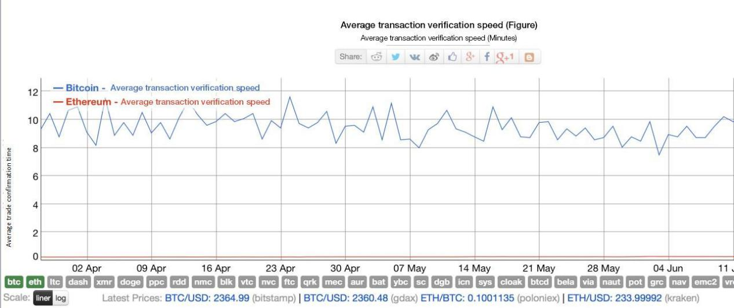

Figure 8: Comparison between transaction confirmation speeds of different technologies

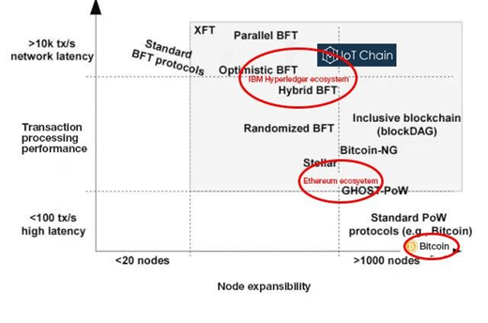

Figure 9: Performance Analysis of ITC execution efficiency

ITC designs following platform architecture (See Figure 10):

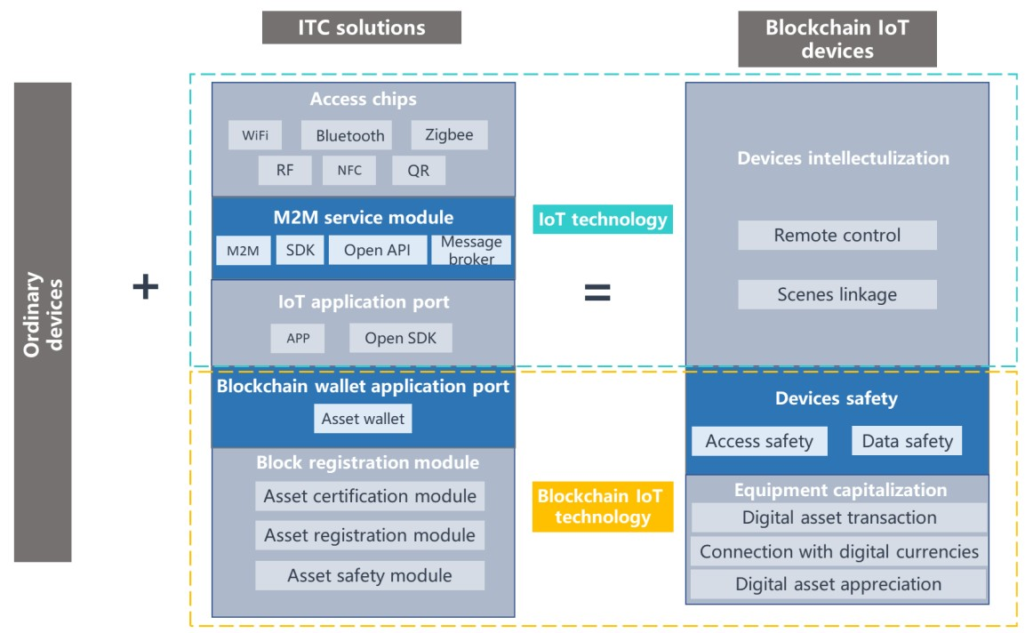

Figure 10: Architecture of ITC platform

Under this architecture, the safety and usability of the project platform has been greatly improved (See Figure 11):

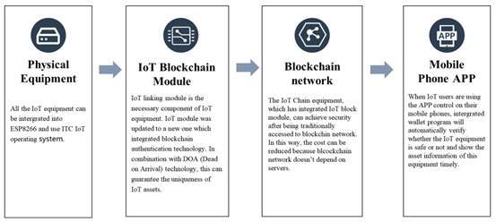

Figure 11: Users’ usage scenario

**3. Our Architecture**

The largest basic architecture of IoT is intelligent lighting devices and their nodes are distributed all over the world. The latest market research report issued by the world’s second biggest market research and consulting company Marketsand Markets points out that by 2020, the scale of intelligent lighting market will reach 8.14 billion dollars and the compound annual rate of growth from 2015 to 2020 will be 22.07%.

According to Ericsson’s prediction, global IoT’s connection scale will rise to 50 billion yuan by 2020. Intelligent furnishing is the most possible pivot of building IoT and making it penetrate into ordinary users. As the commonest entry-level intelligent furnishing appliance, intelligent lighting devices will gain biggest benefits in the development of 5G.

Shanghai Zhuonian Software Research and Development Co., Ltd. is the major provider of IoT technology for global top smart light companies and it has solid foundation and rich resources of operating ITC projects. Compared with projects of the same kind, our project has remarkable technical superiorities (See Chart 2), which will ensure the success of the project.

**Chart 2 Comparison with similar project**

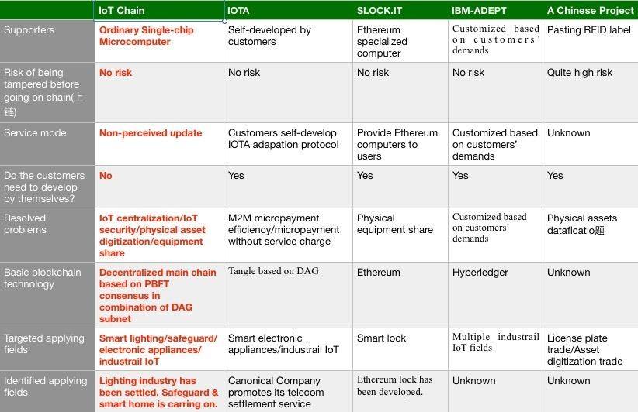

**4. Product planning**

Present IoT system is a centralized intelligent device system and ITC is a P2P node network in essence. Enough nodes are essential to ensure the whole network’s stability. Nodes can be divided into normal type and non-normal type. Normal-type nodes refer to devices which remain open but their operational capability keeps unutilized. But for non-normal devices, once they are open, they will start operating. To avoid power waste caused by POW, we need to find more stable normal-type nodes.

Taking lighting for example, the rotation of earth brings us day and night, and light is necessary at night. In modern society, light comes from lighting equipment which is a normal-type device of huge amounts and can be used to maintain ITC’s stability. For instance, when using Zhuonian lighting cloud products, the users need to log in APP to control the lights. Users cannot use lighting devices until the central server authorizes both the user and the device.

Our technical scheme (See Figure 12 & Figure 13) updates the original intelligent lighting system and utilizes backend verification network as well as ownership to ensure the system will use ITC’s blockchain technology to verify. Thus, we can guarantee that our intelligent lighting system will be safer, faster and more stable than the previous one.

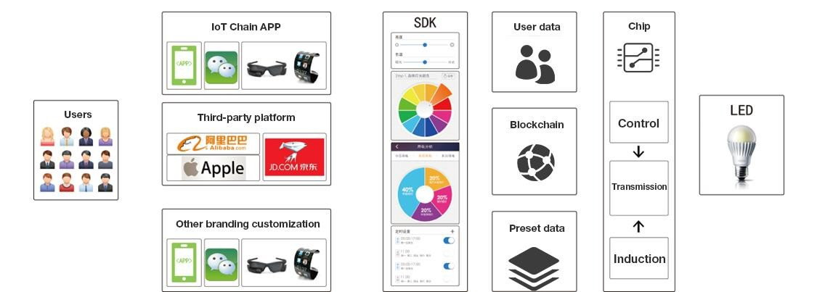

Figure 12: IoT lighting structure of Zhuonian blockchain

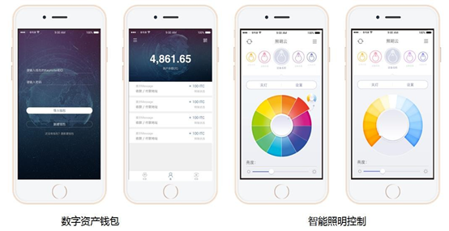

Figure 13: Applications of blockchain IoT lighting

To be more specific, the schedule for research and development of our project as well as product development are as follows (See Figure 14):

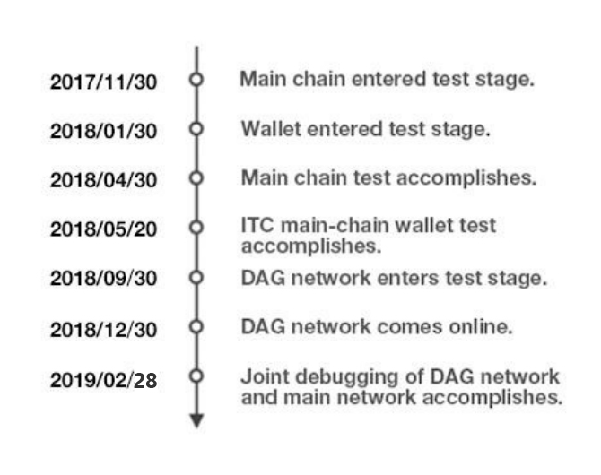

Figure 14: Technology R&D schedule and product development strategies

**5. Cooperative partners**

【Shanghai High-Flying Electronics Technology Co., Ltd.】 is a high-tech enterprise specialized in embedded wireless communication domain, who designs, develops, manufactures and sells complete IOT solutions (Cloud Servers and Intelligent terminal APP) to customers. High-Flying is the module provider for Baidu DuerOS and gained tens of millions of series A-Round investment from Baidu. High-Flying also launched smart light solution provided wireless solution for GE and CREE. The annual turnover of High-Flying is about 140 million yuan, with a shipment of 15 million IoT chips.

**Content of cooperation:** We have reached cooperation intent with High-Flying and IoT chips will be added to ITC project gradually in the future. The ITC operating system will ensure the safety of its underlying IoT devices.

【People’s Daily Digital Communication (Shanghai) Co., Ltd.】is subordinate to People’s Daily and is the only main organization in charge of setting and operating People’s Daily Electronic Reading Column in Shanghai. Up to June, 2017, more than 6,000 People’s Daily electronic reading columns have been set up in Shanghai, becoming the first authorized screen media which is based on Party and government organs (the only one) as well as colleges and universities (the first one) in Shanghai. **Content of cooperation:** We have reached tentative cooperation intent with People’s Daily Digital Communication (Shanghai) Co., Ltd. ITC operating system will ensure the information security of its electronic screens and protect the cloud from being invaded by Hackers releasing harmful information.

【Shenzhen Galaxywind Network System Co., Ltd.】is responsible for research and development of Galaxy Super Computer. Galaxywind provides self-developed high-performance routers for special use or general use, exchange platform and security platform as well as complete solution and technical service of smart home for government and users in all industries.

**Content of cooperation:** We have reached cooperation intent with Galaxywind. IoT chips will be gradually and tentatively added to ITC project in the future. ITC will ensure the underlying safety of its smart devices.

【Shanghai Shuncom Smart Technology Co.,Ltd.】has been dedicated to the field of wireless communication (ZigBee as the core) since its inception in 2004, while expanding the Wi-Fi, GPRS, 4G, Rola, NB-IoT and other communication technologies. Shuncom is a member of Alibaba Smart Living IoT Alliance and took part in Shanghai International Smart Furnishing Exhibition. It also provides the first super-low-power-consumption module in this industry for Haier cloud lock.

**Content of cooperation:** We have reached cooperation intent with Galaxywind. Lighting chips will be gradually and tentatively added to ITC project in the future. ITC will ensure the underlying safety of its IoT lighting devices.

【Telink Semiconductor (Shanghai) Co., Ltd.】The annual marketing turnover of Telink is about 400 million yuan and it has gained Intel’s strategic investment. The current product portfolio of Telink is design and sale of integrated circuit chips. It also provides relevant technology consulting and technical service. Telink covers numerous markets including smart lighting, smart furnishing, wearable products, and wireless peripheral, wireless toy, industry control, smart city as well as other IoT and consumer electronics.

On 2016 Apple’s New Product Release Meeting, Telink became Apple’s cooperative partner. GE has adopted Telink’s BLE Mesh technology in its smart lighting. Besides, Telink was recently listed on *2016 Global Most Notable Newly-developing Semiconductor Enterprises* selected by EE Times.

**Content of cooperation:** We have reached cooperation intent with Telink and IoT chips will be gradually added to ITC project in the future. The ITC operating system will ensure the safety of its underlying IoT devices.

【Shanghai Be-Tiger Network Technology Co.,Ltd.】was founded in 2015 and the first to create the brand new outdoor media - TBA (Taxi Back-window Advertising). Be-tiger has long devoted to internet application in automobiles, building man-automobile internet ecosystem through cloud computing and many professional technical methods.

**Content of cooperation:** We have reached cooperation intent with Be-tiger and display device will be gradually added to ITC project in the future. The ITC operating system will ensure the safety of its underlying IoT devices. Since outdoor advertising medium is sensitive industry, it will cause great harm to the society if bad information is released by hackers who invade its centralized delivering cloud. ITC technology can efficiently protect the safety of advertisement contents.

【Shenzhen Lenze Technology Co.,Ltd.】：The annual shipment of Lenze Technology is about 150 million chips. It is a professional major chip provider of sharing smart hardware. It is the core provider of smart lock’s chip for Xiaoming sharing bikes and it’s also the provider of major chips for sharing –device industry. Lenze is a high-tech enterprise, which integrates the research, development and decoding scheme selling of the blutooth chip—Module Host Audio.

**Content of cooperation:** We have reached cooperation intent with Lenze and IoT chips will be gradually added to ITC project in the future. The ITC operating system will ensure the safety of its underlying IoT devices and help realizing the sharing of everything.

**Chapter III Team Members**

The team members of our project are all senior experts in smart hardware and algorithm field with rich experience in starting up business. Besides, we have employed industry elites as project consultants. The members are:

**【Core Team】**

**CEO: Xie Zhuopeng**

Xie Zhuopeng is a senior entrepreneur and expert in IoT field. He has been engaged in smart hardware field for four years and has profoundly studied blockchain for three years. Xie has deep insights in smart hardware and was invited to address speech in many summits of smart hardware. He has participated in designing smart lighting architecture for several lighting companies at home and abroad. Besides, he has taken part in many designs of smart hardware architecture.

**CTO: Ding Yin**

Ding Yin has worked on development of chip’s firmware for 12 years, having experience in digital image, 3D model retrieval, compression algorithm processing of audio and video and financial software of bank card. Ding has deep understanding of chip’s hardware, embedded software structure and encryption algorithm.

**CFO: Zhao Tan**

Zhao Tan, MBA of MIT, CPA of China, Singapore and United Kindom (chartered). He once was the Asia Pacific CFO of Kerry and was in charge of foreign exchange hedging of hundreds of millions of dollars, strategic planning of cross-border capital, management of cash flow and building banking business system (J.P. Morgan). He once worked on auditing and IPO in China and Singapore’s KPMG. Zhao has abundant experience in financial management, financing and IPO and is quite interested in financial techniques innovation.

**Major Programmer: Liao Dongnian**

Liao has engaged in smart hardware field for four years and led in designing the smart lighting architecture of the world’s top-one lighting company. He has studied

blockchain technology for three years and mastered java, C++, ruby, mqtt and blockchain

**Major Programmer: Hu Yasheng**

Hu has engaged in smart hardware field for four years and started to do research in blockchain IoT technology since 2013. He once participated in researching and developing IoT architecture design of an international famous brand. Also, he once was the technical manager of installment business department of Tongcheng Tourism Petty Loan.

**【Consultant Team】**

**Liang Ran：** As an expert in blockchain technology, Liang mainly studies the issue and transaction of assets in blockchain. He co-edited the *ChinaLedger Whitepaper* as well as *China Blockchain Technology and Application Development Whitepaper* issued by MIIT and he is the judge of MIIT First China Blockchain Development Contest. Also, he is the co-founder of RippleFox (RippleFox is China’s biggest Ripple and Stellar’s gateway and the leader of Chinese community of both Ripple and Stellar.

**Zhou Shuoji:** Zhou is the founding partner of FBG and he is an expert in digital currency transaction as well as an active investor in blockchain field. As one of China’s early pioneer practitioner of blockchain technology and the opinion leader of China digital currency community, Zhou has started and managed two digital-currency private transaction funds.

**Ma Zhiwei:** Vice president of Opple Lighting Co., Ltd (603515). After Opple’s going public, it became the world’s largest lighting company with more than 30 million yuan market value.

**Ji Xinhua:** Master of Shanghai Jaitong University and winner of first prize of Shanghai science and technology advancement. Ji took part in establishing standards for Unionpay credit cards’ encryption chips and for Central Bank’s digital currency.

**Sheng Wenjun:** Founder of Telink. He got his bachelor, master and doctor

degree from Tsinghua University. Telink gained Intel strategic investment and is also the cooperative partner of IoT.

**Qiu Haiyi:** Founder and general manager of High-Flying. High-Flying is the distributor of Ai chips and the only IoT enterprise invested by Baidu. The annual turnover of High-Flying is about 150 million yuan.

**References**

[1] Bahga A, Madisetti V K. Blockchain platform for industrial Internet of Things [J]. J. Softw. Eng. Appl, 2016, 9(10): 533. Castro M, Liskov B. Practical Byzantine fault tolerance[C]//OSDI. 1999, 99: 173-186.

[2] Castro M, Liskov B. Practical Byzantine fault tolerance[C]//OSDI. 1999, 99:

173-186.

[3] Cachin C. Architecture of the Hyperledger blockchain fabric[C]//Workshop on

Distributed Cryptocurrencies and Consensus Ledgers. 2016.

[4] Miller A, Xia Y, Croman K, et al. The Honey Badger of BFT Protocols[C]// ACM Sigsac Conference on Computer and Communications Security. ACM,

2016:31-42.

[5] Nakamoto S. Bitcoin: A peer-to-peer electronic cash system [J]. 2008.

[6] Jia Chang, Feng Han. Blockchain: from digital currency to credit society [J].

2016. Beijing, CITIC Publishing House

[7] People on nxtforum.org (2014) DAG, a generalized blockchain. https://nxtforum.org/proof-of-stake-algorithm/dag-a-generalized-blockchain/ (registration at nxtforum.org required).

[8] Lee J, Bagheri B, Kao H A. A cyber-physical systems architecture for industry

4.0-based manufacturing systems [J]. Manufacturing Letters, 2015, 3: 18-23.

1. ChainCode was first brought up by IBM and it refers to smart contract mentioned on Ethereum.
2. CPS refers to the architecture design for IoT ecosystem of ITC rather than some certain technical details.